**Meetings in Agile**

Agile methodologies, particularly Scrum, emphasize frequent and time-boxed meetings to promote transparency, inspection, and adaptation. These meetings are essential to maintain alignment between team members, stakeholders, and customers.

Agile meetings promote:

1. **Frequent collaboration**
2. **Early detection of blockers**
3. **Continuous improvement**
4. **Adaptability to change**

The core Agile meetings include:

1. **Sprint Planning**
2. **Daily Scrum (Stand-up)**
3. **Sprint Review**
4. **Sprint Retrospective**

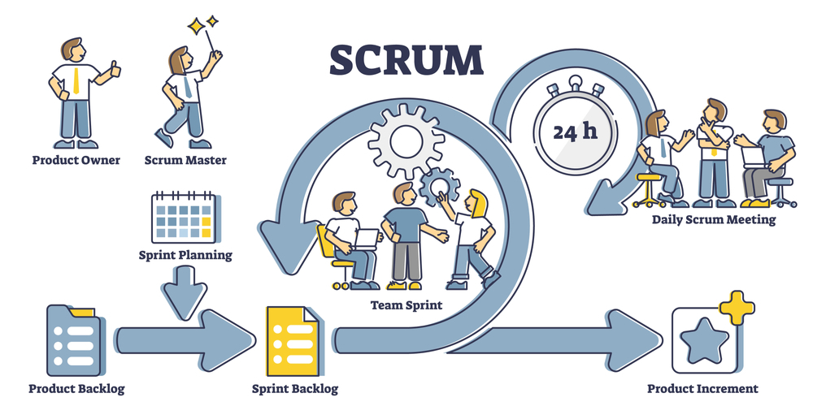

**Types of Agile Meetings in Project Management**:

* 1. **Sprint Planning Meeting:**

The sprint planning meeting sets the foundation for the upcoming sprint. The team collaborates to define the sprint goal, decide what work will be done, and assign tasks accordingly.

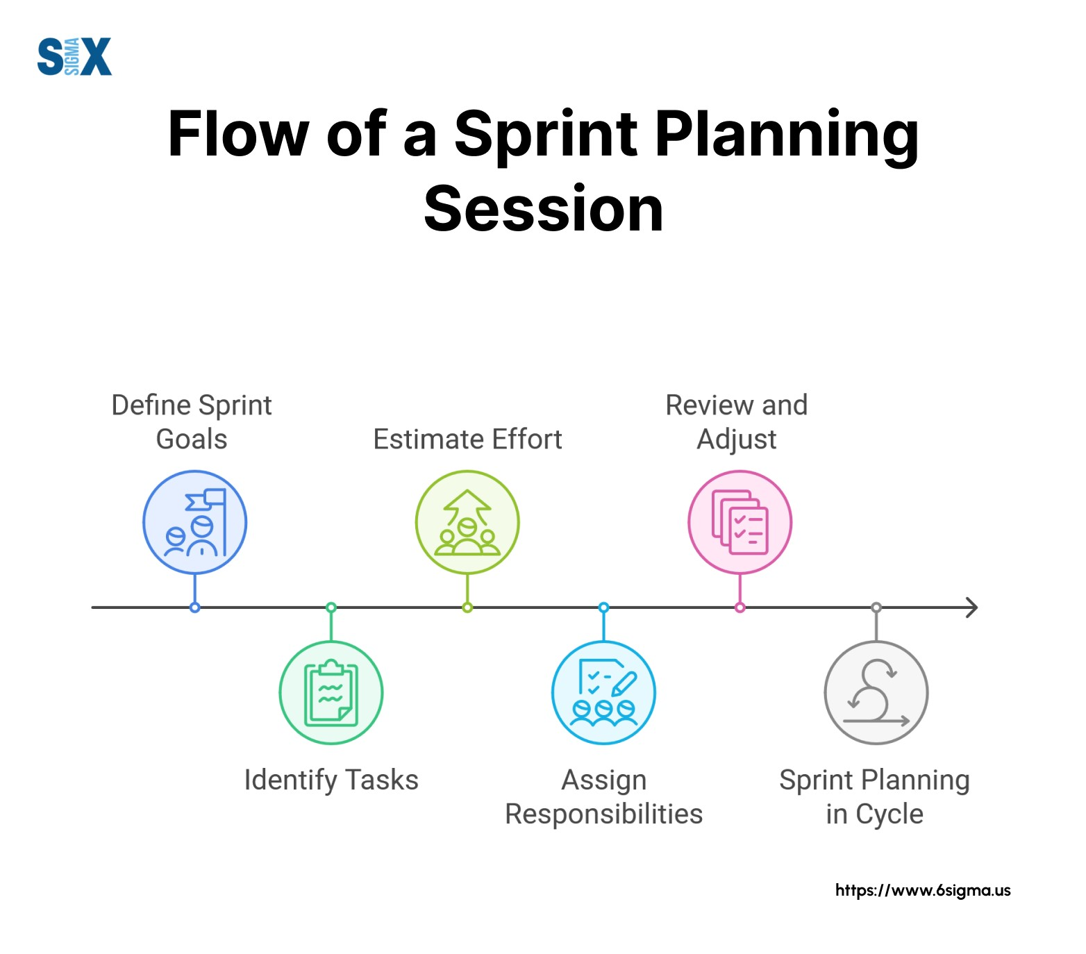

**Timing & Duration:**

* Conducted at the start of each sprint
* Duration: 2–4 hours for a 2-week sprint (up to 8 hours for a 4-week sprint)

**Participants:**

* Product Owner (PO)
* Scrum Master (SM)
* Development Team

**Purpose:**

* Plan the work to be accomplished in the upcoming sprint
* Define the Sprint Goal

**Goals:**

* Decide specific tasks and features to work on
* Assign responsibilities and clarify scope
* Define the Sprint Goal aligned with business needs

**How to Conduct It Effectively:**

* Keep it short & focused: Avoid off-topic discussions
* Prepare well: Updated backlog, team availability
* Set a clear agenda: Define and prioritize goals
* Break down tasks: Estimate effort and assign work
* Clarify doubts: Ensure everyone understands their role
* Wrap up: Confirm action plan and Sprint Goal

**Result:** A well-structured sprint backlog and a clear direction for the sprint.

* 1. **Daily Scrum (Stand-up) Meeting**

A short, daily team meeting to review progress, identify blockers, and ensure alignment.

**Timing & Duration:**

* Held every day of the sprint
* Fixed time and location
* Duration: 15 minutes (strictly time-boxed)

**Participants:**

* Development Team (mandatory)
* Scrum Master (facilitator)
* Product Owner (optional)

**Purpose:**

* Share daily progress and highlight blockers
* Sync the team and adjust as needed

**Each team member answers:**

1. What did I do yesterday?
2. What will I do today?
3. Are there any impediments?

How to Conduct It Effectively:

* Keep it short: Only 15 minutes
* Consistent time/place: Builds routine
* Encourage participation: Everyone speaks
* Focus on alignment: Not for deep discussions
* Log blockers: Resolve them separately
* Follow-up: Ensure tasks are progressing

**Result:** Team remains aligned and aware of each other’s progress; early issue detection.

**3. Sprint Review Meeting**

This meeting is held at the end of each sprint to demonstrate the work completed to stakeholders and gather feedback.

**Timing & Duration:**

* Conducted at the end of each sprint
* Duration: 1–2 hours (for a 2-week sprint)

**Participants:**

* Development Team
* Product Owner
* Scrum Master
* Stakeholders (e.g., clients, managers, business users)

**Purpose:**

* Showcase completed work
* Get stakeholder feedback
* Adapt the Product Backlog

**How to Make It Effective:**

* Practice & rehearse demos
* Highlight business value
* Structure the meeting:
  + Sprint accomplishments
  + Live demos of completed features
  + Feedback collection
  + Future direction
* Actively involve stakeholders
* Document feedback and action items

**Result:**  
A reviewed increment, valuable feedback from stakeholders, and updated priorities for upcoming sprints.

1. **Sprint Retrospective Meeting**

Conducted after the sprint review to evaluate the sprint and identify opportunities for improvement.

**Timing & Duration:**

* Conducted after the Sprint Review
* Duration: 1.5–3 hours depending on sprint length

**Participants:**

* Development Team
* Scrum Master
* Product Owner (optional)

**Purpose:**

* Reflect on the sprint
* Identify and act on improvement areas

**Goals:**

* Discuss what went well
* Highlight what didn’t
* Agree on action items for improvement

How to Conduct It Productively:

* Set a clear agenda: Topics prepared in advance
* Start with positives: Acknowledge successes
* Use structured frameworks:
  + Mad/Sad/Glad
  + Sailboat
  + Starfish
  + Mountain Climber
* Avoid blame: Focus on solutions
* Assign actionable improvements
* Track follow-ups in next sprint

**Result:** A continuously improving team with enhanced collaboration, processes, and morale.

| **Agile Meeting** | **When It Happens** | **Duration** | **Key Participants** | **Purpose** |
| --- | --- | --- | --- | --- |
| Sprint Planning | Start of each sprint | 2–4 hours | PO, SM, Dev Team | Define Sprint Goal and Sprint Backlog |
| Daily Scrum | Every day during sprint | 15 minutes | Dev Team, SM | Sync progress, raise blockers |
| Sprint Review | End of each sprint | 1–2 hours | Dev Team, PO, Stakeholders | Demo work, collect feedback |
| Retrospective | After Sprint Review | 1.5–3 hours | Dev Team, SM, (PO optional) | Reflect and improve team practices |